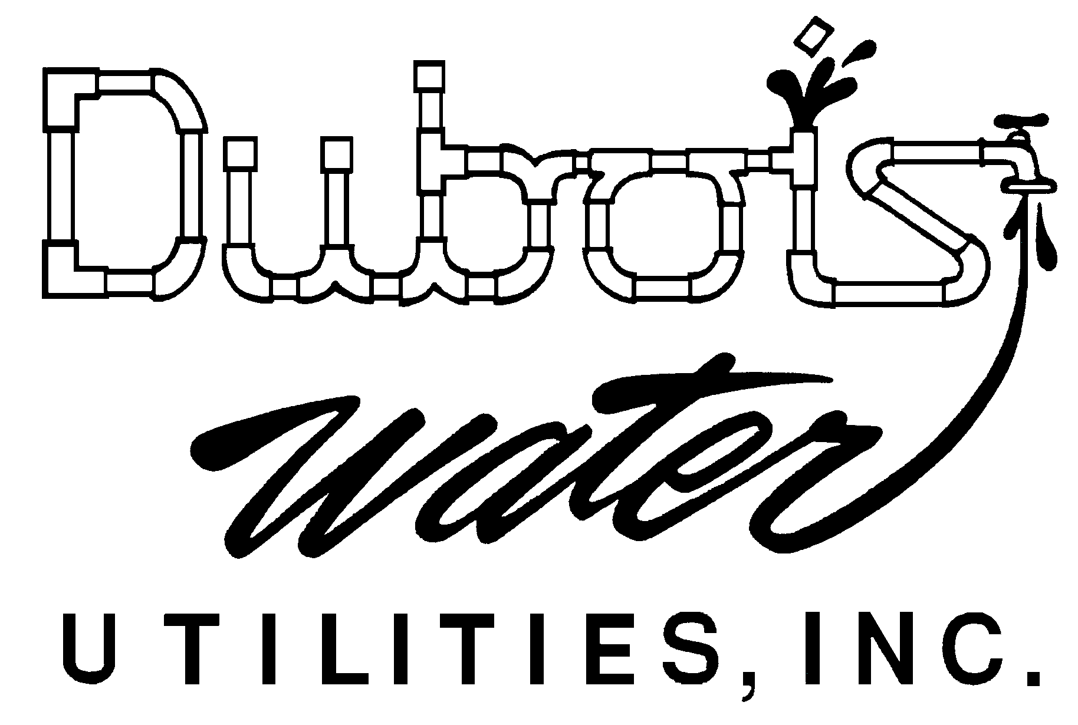
DIRECT PAY
ACH PROGRAM

AUTHORIZATION AGREEMENT FOR DIRECT PAYMENTS

Customer Name(s):___________________________________________________________________________

Utility Account Number: ____________________________ Telephone: ________________________________

Utility Service Address: _______________________________________________________________________

Billing Address (if different) ____________________________________________________________________________

I/We hereby authorize Dubois Water Utilities, Inc. (Dubois Water) to initiate debit entries and, if necessary, credit or adjustments for any debit entries in error to my/our account at the Financial Institution (Depository) described below for the purpose of making monthly payments to my/our utility account. Said debits are to commence in such time and manner as to afford Dubois Water a reasonable time to act on this authorization. I/We also acknowledge that if the account identified below becomes inactive, closed, or contain insufficient funds to cover the amount of the debit, I will be billed the returned check fee charges as set forth in Dubois Water’s non-recurring charges policy in effect at the time, that this authorization shall be terminated; and, that my/our utility account shall be considered unpaid on the due date, shall be assessed late payment penalties, and may be subject to termination of utility services if my/our utility account remains unpaid.

DEPOSITORY INFORMATION

Financial Institution Name: ____________________________________________________________________

Address: ______________________________ City: ____________________ State: _____ Zip: _____________

___ Individual Account ___ Company Account ___ Other: ___________________________

___ Checking Account Please attach a voided check below.

___ Savings Account Please provide the following information:

Routing Number ____________________________ Account Number ________________________________

This authorization is to remain in full force and effect until Dubois Water has received written notification from me (or either of us), or
my/our authorized representative, of its termination in such time and in such manner as to afford Dubois Water, and Depository, a
reasonable opportunity to act on it.

__________________________________ ________________________________ Date: ____________
Signature Signature

Attach voi Attach voided check here.

